SIMATS ENGINEERING ASSESSMENT TOOL 3
COURSE NAME: Fundamentals of Data Science COURSE CODE: DSA04

COURSE OUTCOME COVERED
CO1: Analyse the role of data science, facets of data, and the big data ecosystem for informed decision-making. (BL2)

QUESTIONS: 05 Total Marks:100
Annexure A
Exploratory Data Analysis - Based Practical Assessment

Code of Conduct:
I SHAGITHIYAN N (192324259) certify that this submission is my original work and that I have adhered to the guidelines specified for this assessment.
I understand that any violation of academic integrity rules will result in disciplinary action.
Signature of the student: Shagithiyan N
Annexure A
Exploratory Data Analysis-Based Practical Assessment

- Education Analytics Dataset Question 1
A college wants to analyze student performance based on attendance, study hours, internal marks, and final result. Perform EDA to identify the factors affecting student results.
Student_I D | Attendanc e | Study_Hour s | Internal_Mark s | Resul t
S01 | 92 | 5 | 45 | Pass
S02 | 55 | 2 | 24 | Fail
S03 | 78 | 4 | 38 | Pass
S04 | 60 | 3 | 28 | Fail
S05 | 88 | 5 | 42 | Pass
S06 | 47 | 1 | 20 | Fail
S07 | 95 | 6 | 48 | Pass
S08 | 72 | 3 | 35 | Pass
S09 | 50 | 2 | 22 | Fail
S10 | 83 | 4 | 40 | Pass
S11 | 66 | 3 | 30 | Fail
S12 | 90 | 5 | 44 | Pass
S13 | 58 | 2 | 25 | Fail
S14 | 76 | 4 | 36 | Pass
S15 | 62 | 3 | 29 | Fail
S16 | 85 | 5 | 41 | Pass
S17 | 45 | 1 | 18 | Fail
S18 | 80 | 4 | 39 | Pass
S19 | 68 | 3 | 32 | Pass
S20 | 53 | 2 | 23 | Fail

ANSWER:

import pandas as pd
import matplotlib.pyplot as plt

# Create the dataset data = {
"Student_ID": [
"S01", "S02", "S03", "S04", "S05",
"S06", "S07", "S08", "S09", "S10",
"S11", "S12", "S13", "S14", "S15",
"S16", "S17", "S18", "S19", "S20"
],
"Attendance": [
92, 55, 78, 60, 88, 47, 95, 72, 50, 83,

66, 90, 58, 76, 62, 85, 45, 80, 68, 53
],
"Study_Hours": [
5, 2, 4, 3, 5, 1, 6, 3, 2, 4,
3, 5, 2, 4, 3, 5, 1, 4, 3, 2
],
"Internal_Marks": [
45, 24, 38, 28, 42, 20, 48, 35, 22, 40,
30, 44, 25, 36, 29, 41, 18, 39, 32, 23
],
"Result": [
"Pass", "Fail", "Pass", "Fail", "Pass",
"Fail", "Pass", "Pass", "Fail", "Pass",
"Fail", "Pass", "Fail", "Pass", "Fail",
"Pass", "Fail", "Pass", "Pass", "Fail"
]
}
df = pd.DataFrame(data) # Display dataset
print("EDUCATION ANALYTICS DATASET")
print(df)
# 1. Number of rows and columns print("\n1. SHAPE OF DATASET")
print("Number of rows:", df.shape[0]) print("Number of columns:", df.shape[1])
# 2. Data types
print("\n2. DATA TYPES") print(df.dtypes)
# 3. Missing and duplicate values print("\n3. MISSING VALUES")
print(df.isnull().sum())
print("Duplicate rows:", df.duplicated().sum()) print("Duplicate Student IDs:",
df["Student_ID"].duplicated().sum())
# 4. Statistical analysis numeric_cols = [
"Attendance", "Study_Hours", "Internal_Marks"
]

print("\n4. DESCRIPTIVE STATISTICS")
print(df[numeric_cols].describe()) print("\nMEDIAN")

print(df[numeric_cols].median())
print("\nSTANDARD DEVIATION")
print(df[numeric_cols].std())
# Additional analysis print("\nRESULT COUNTS") print(df["Result"].value_counts())
print("\nAVERAGE VALUES BY RESULT")
print(
df.groupby("Result")[numeric_cols]
.mean().round(2)
)
# 5. Four charts using subplots
fig, axes = plt.subplots(2, 2, figsize=(12, 8))
# Chart 1: Bar chart
result_counts = df["Result"].value_counts().reindex( ["Pass", "Fail"], fill_value=0
)
result_counts.plot(kind="bar", ax=axes[0, 0]) axes[0, 0].set_title("Number of Students by Result") axes[0, 0].set_xlabel("Result")
axes[0, 0].set_ylabel("Number of Students") axes[0, 0].tick_params(axis="x", rotation=0)
# Chart 2: Histogram axes[0, 1].hist(
df["Attendance"], bins=6, edgecolor="black"
)
axes[0, 1].set_title("Distribution of Attendance") axes[0, 1].set_xlabel("Attendance (%)")
axes[0, 1].set_ylabel("Number of Students")
# Chart 3: Scatter plot
for result in ["Pass", "Fail"]:
subset = df[df["Result"] == result] axes[1, 0].scatter(
subset["Study_Hours"], subset["Internal_Marks"], label=result
)
axes[1, 0].set_title("Study Hours vs Internal Marks") axes[1, 0].set_xlabel("Study Hours")
axes[1, 0].set_ylabel("Internal Marks") axes[1, 0].legend()

# Chart 4: Box plot df.boxplot(
column="Internal_Marks", by="Result",
ax=axes[1, 1]
)
axes[1, 1].set_title("Internal Marks by Result") axes[1, 1].set_xlabel("Result")
axes[1, 1].set_ylabel("Internal Marks")
# Display all charts in one figure fig.suptitle("Education Analytics - EDA") plt.tight_layout()
plt.show()

OUTPUT:

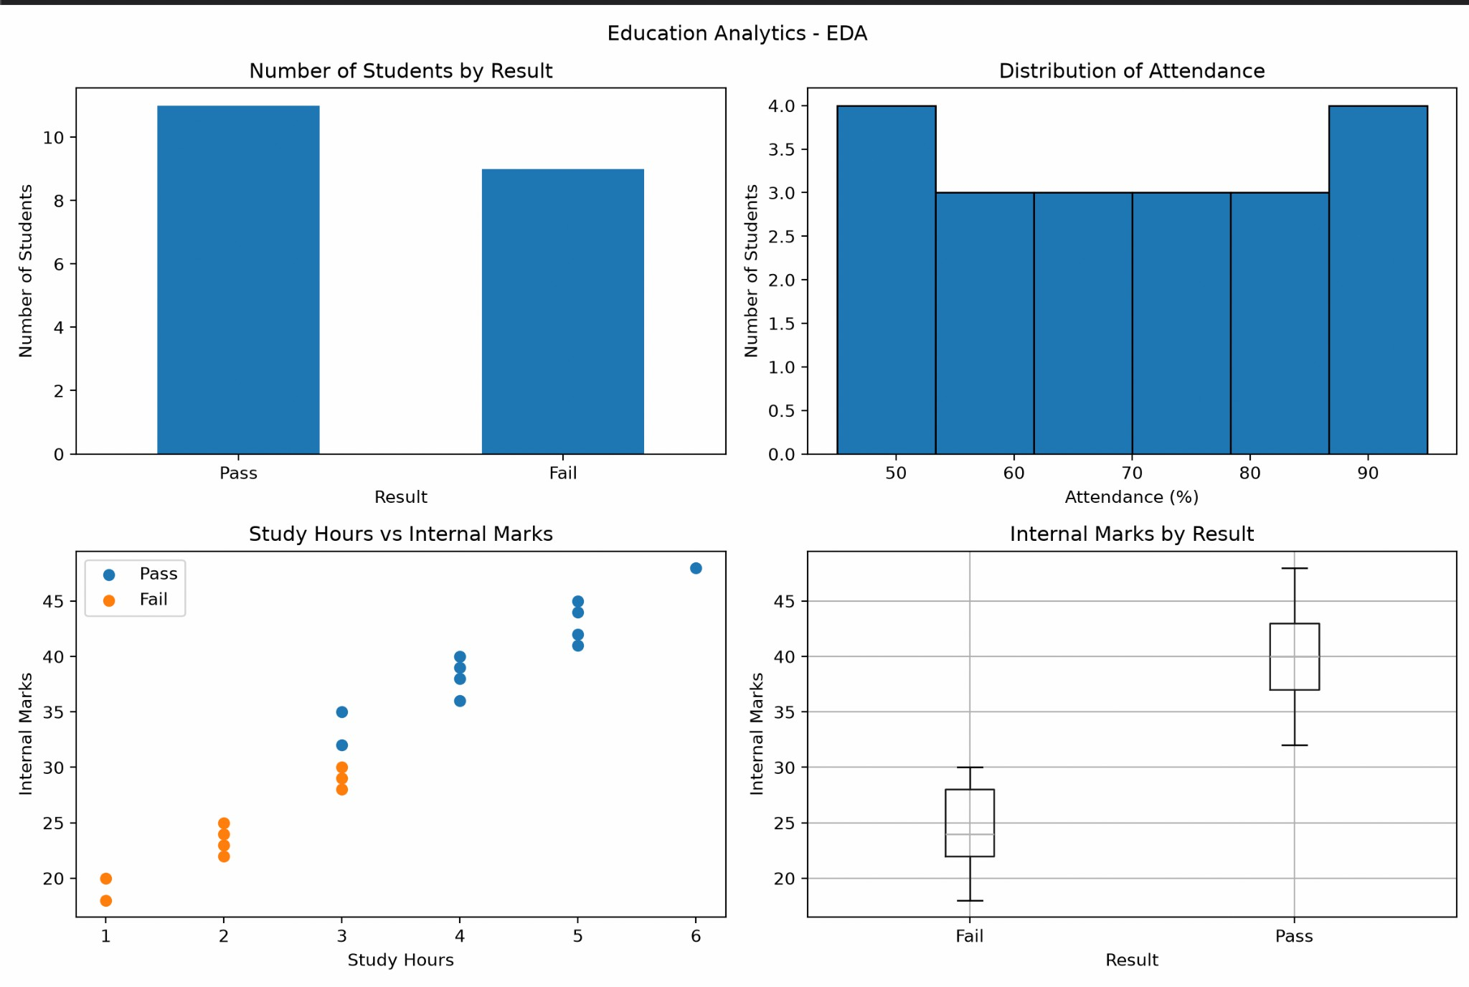

Observations
- Out of 20 students, 11 passed and 9 failed.
- Students who passed generally had higher attendance.
- Students who studied for more hours generally obtained higher internal marks.
- In this dataset, passing students scored between 35 and 48, while failing students scored between 18 and 30.
- Attendance, study hours and internal marks are useful indicators for understanding student performance.

Conclusion
Exploratory Data Analysis was performed successfully on the Education Analytics Dataset using Python, Pandas and Matplotlib. The dataset was examined for its dimensions, data types, missing values, duplicate records and descriptive statistics. Four charts were created using subplots in a single figure. The analysis suggests that attendance, study hours and internal marks are associated with student results.

Healthcare Analytics Dataset Question 2
A hospital wants to analyze patient health risk based on age, blood sugar, blood pressure, BMI, and disease status. Perform EDA to find important health patterns.
Patient_I D | Ag e | Sugar_Lev el | BP | BMI | Disease_Stat us
P01 | 45 | 145 | 13  0 | 28 | Yes
P02 | 32 | 98 | 11  8 | 23 | No
P03 | 55 | 180 | 14  5 | 31 | Yes
P04 | 28 | 90 | 11  0 | 22 | No
P05 | 60 | 200 | 15  0 | 34 | Yes
P06 | 40 | 120 | 12  5 | 26 | No
P07 | 52 | 165 | 14  0 | 30 | Yes
P08 | 35 | 105 | 12  0 | 24 | No
P09 | 48 | 155 | 13  5 | 29 | Yes
P10 | 30 | 95 | 11  5 | 23 | No
P11 | 62 | 210 | 15  5 | 35 | Yes
P12 | 38 | 115 | 12  2 | 25 | No
P13 | 50 | 170 | 14  2 | 30 | Yes
P14 | 27 | 88 | 10  8 | 21 | No
P15 | 58 | 190 | 14  8 | 33 | Yes
P16 | 42 | 130 | 12  8 | 27 | No
P17 | 46 | 150 | 13  2 | 28 | Yes
P18 | 34 | 100 | 11  6 | 24 | No
P19 | 53 | 175 | 14  4 | 31 | Yes
P20 | 29 | 92 | 11  2 | 22 | No

ANSWER:

import pd import

matplotlib.pyplot as plt # Create the dataset
pandas as

data = {
"Patient_ID": [
"P01", "P02", "P03", "P04", "P05",
"P06", "P07", "P08", "P09", "P10",
"P11", "P12", "P13", "P14", "P15",
"P16", "P17", "P18", "P19", "P20"
], "Age": [
45, 32, 55, 28, 60, 40, 52, 35, 48, 30,
62, 38, 50, 27, 58, 42, 46, 34, 53, 29
],
"Sugar_Level": [
145, 98, 180, 90, 200, 120, 165, 105, 155, 95,
210, 115, 170, 88, 190, 130, 150, 100, 175, 92
], "BP": [
130, 118, 145, 110, 150, 125, 140, 120, 135, 115,
155, 122, 142, 108, 148, 128, 132, 116, 144, 112
], "BMI": [
28, 23, 31, 22, 34, 26, 30, 24, 29, 23,
35, 25, 30, 21, 33, 27, 28, 24, 31, 22
],
"Disease_Status": [
"Yes", "No", "Yes", "No", "Yes",
"No", "Yes", "No", "Yes", "No",
"Yes", "No", "Yes", "No", "Yes",
"No", "Yes", "No", "Yes", "No"
]
}
df = pd.DataFrame(data) # Display the dataset
print("HEALTHCARE ANALYTICS DATASET")
print(df)
# 1. Number of rows and columns print("\n1. SHAPE OF DATASET")
print("Number of rows:", df.shape[0]) print("Number of columns:", df.shape[1])
# 2. Data types
print("\n2. DATA TYPES") print(df.dtypes)
# 3. Missing and duplicate values print("\n3. MISSING VALUES")
print(df.isnull().sum())

print("Duplicate rows:", df.duplicated().sum()) print("Duplicate Patient IDs:",
df["Patient_ID"].duplicated().sum())
# 4. Statistical analysis
numeric_cols = ["Age", "Sugar_Level", "BP", "BMI"]
print("\n4. DESCRIPTIVE STATISTICS")
print(df[numeric_cols].describe())
print("\nMEDIAN") print(df[numeric_cols].median())
print("\nSTANDARD DEVIATION")
print(df[numeric_cols].std())
print("\nAVERAGE VALUES BY DISEASE STATUS")
print(
df.groupby("Disease_Status")[numeric_cols]
.mean().round(2)
)
print("\nDISEASE STATUS COUNTS")
print(df["Disease_Status"].value_counts())
# 5. Four charts using subplots
fig, axes = plt.subplots(2, 2, figsize=(12, 8))
# Chart 1: Bar chart df["Disease_Status"].value_counts().reindex(
["Yes", "No"], fill_value=0
).plot(kind="bar", ax=axes[0, 0])
axes[0, 0].set_title("Disease Status of Patients") axes[0, 0].set_xlabel("Disease Status")
axes[0, 0].set_ylabel("Number of Patients") axes[0, 0].tick_params(axis="x", rotation=0)

# Chart 2: Histogram of sugar level axes[0, 1].hist(
df["Sugar_Level"], bins=6, edgecolor="black"
)

axes[0, 1].set_title("Distribution of Sugar Levels") axes[0, 1].set_xlabel("Sugar Level")
axes[0, 1].set_ylabel("Number of Patients")

# Chart 3: Scatter plot of age and sugar level for status in ["Yes", "No"]:
subset = df[df["Disease_Status"] == status]

axes[1, 0].scatter( subset["Age"], subset["Sugar_Level"], label=status
)
axes[1, 0].set_title("Age vs Sugar Level") axes[1, 0].set_xlabel("Age")
axes[1, 0].set_ylabel("Sugar Level") axes[1, 0].legend(title="Disease Status")
# Chart 4: Box plot of BMI by disease status df.boxplot(
column="BMI", by="Disease_Status", ax=axes[1, 1]
)
axes[1, 1].set_title("BMI by Disease Status") axes[1, 1].set_xlabel("Disease Status") axes[1, 1].set_ylabel("BMI")
# Display all four charts in one figure fig.suptitle("Healthcare Analytics - EDA") plt.tight_layout()
plt.show()

OUTPUT:

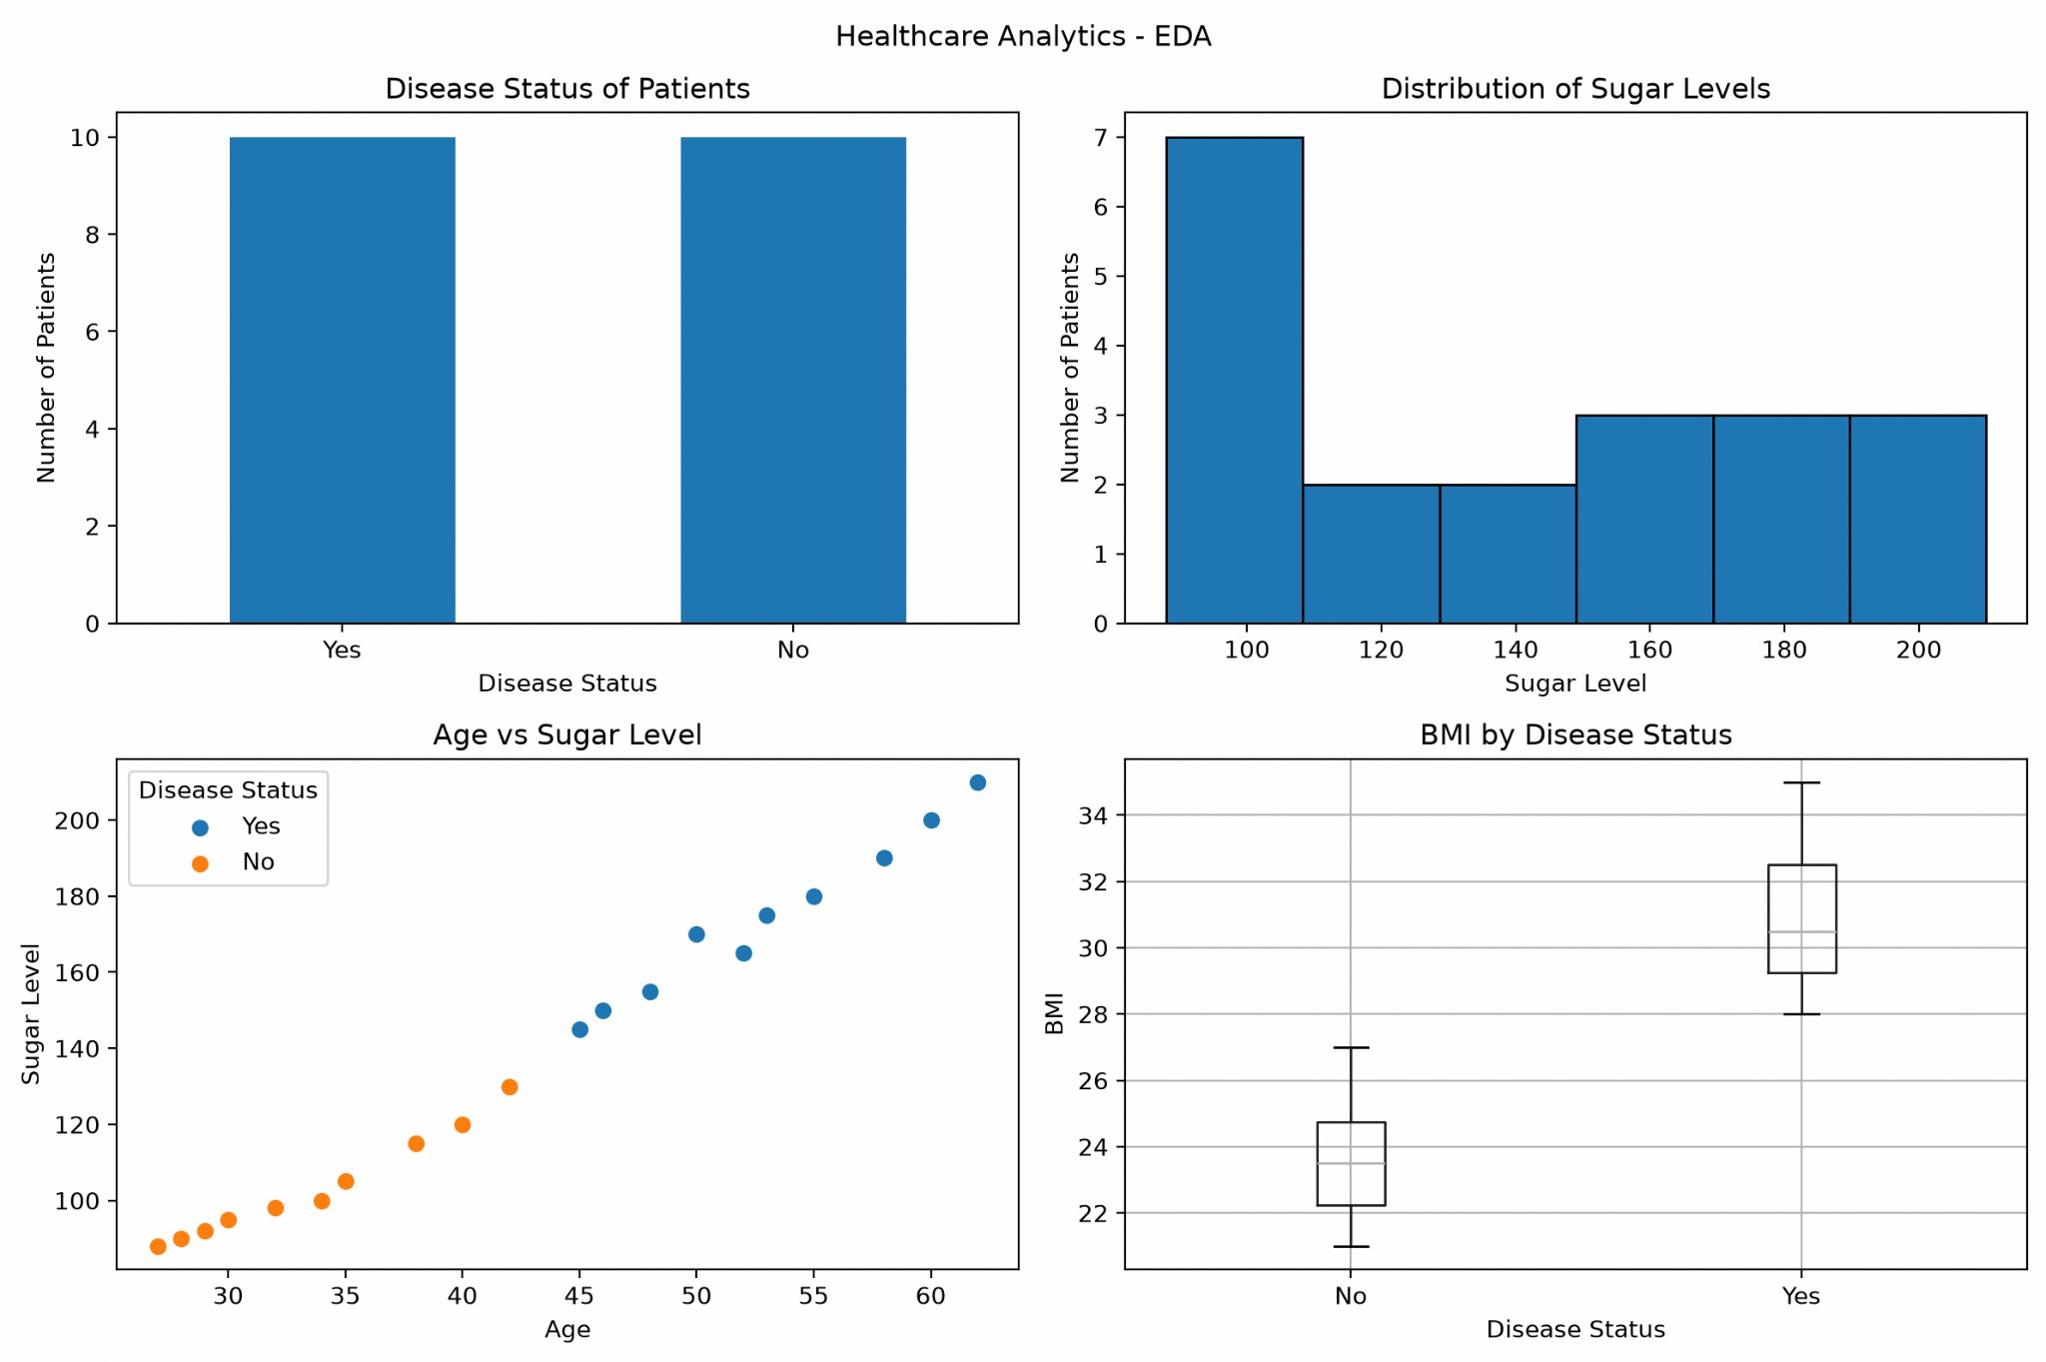

Observations
- Out of 20 patients, 10 have a disease status of Yes and 10 have a disease status of No.
- Patients marked Yes have a higher average age (52.9 years) than patients marked No (33.5 years).
- The average sugar level is higher among patients marked Yes (174) than among patients marked No (103.3).
- Patients marked Yes have a higher average blood pressure (142.1) than patients marked No (117.4).
- The average BMI is higher among patients marked Yes (30.9) than among patients marked No (23.7).

Conclusion
Exploratory Data Analysis was successfully performed on the Healthcare Analytics Dataset using Python, Pandas and Matplotlib. The dataset was examined using descriptive statistics and four visualizations displayed in a single figure using subplots. The analysis shows differences in age, sugar level, blood pressure and BMI between the two disease-status groups. These patterns may help identify variables for further healthcare analysis, but the small dataset does not establish medical diagnoses or prove that these factors cause disease.

Retail Sales Dataset Question 3
A supermarket wants to analyze product sales based on category, price, quantity sold, discount, and revenue. Perform EDA to identify high-selling products and revenue patterns.
Product_I D | Categor y | Pric e | Quantity_Sol d | Discou nt | Revenu e
PR01 | Grocery | 50 | 20 | 5 | 1000
PR02 | Snacks | 30 | 35 | 3 | 1050
PR03 | Dairy | 45 | 18 | 2 | 810
PR04 | Fruits | 60 | 25 | 5 | 1500
PR05 | Vegetabl es | 40 | 30 | 4 | 1200
PR06 | Grocery | 80 | 15 | 6 | 1200
PR07 | Snacks | 25 | 40 | 3 | 1000
PR08 | Dairy | 55 | 16 | 2 | 880
PR09 | Fruits | 70 | 22 | 5 | 1540
PR10 | Vegetabl es | 35 | 28 | 4 | 980
PR11 | Grocery | 90 | 12 | 6 | 1080
PR12 | Snacks | 20 | 45 | 2 | 900
PR13 | Dairy | 65 | 14 | 3 | 910
PR14 | Fruits | 75 | 20 | 5 | 1500
PR15 | Vegetabl es | 45 | 26 | 4 | 1170
PR16 | Grocery | 100 | 10 | 7 | 1000
PR17 | Snacks | 35 | 32 | 3 | 1120
PR18 | Dairy | 50 | 19 | 2 | 950
PR19 | Fruits | 80 | 18 | 6 | 1440
PR20 | Vegetabl es | 30 | 35 | 3 | 1050

ANSWER:

import pandas as pd
import matplotlib.pyplot as plt

# Create the dataset data = {
"Product_ID": [
"PR01", "PR02", "PR03", "PR04", "PR05",
"PR06", "PR07", "PR08", "PR09", "PR10",
"PR11", "PR12", "PR13", "PR14", "PR15",
"PR16", "PR17", "PR18", "PR19", "PR20"
],
"Category": [
"Grocery", "Snacks", "Dairy", "Fruits", "Vegetables",

"Grocery", "Snacks", "Dairy", "Fruits", "Vegetables",
"Grocery", "Snacks", "Dairy", "Fruits", "Vegetables", "Grocery", "Snacks", "Dairy", "Fruits", "Vegetables"
],
"Price": [
50, 30, 45, 60, 40, 80, 25, 55, 70, 35,
90, 20, 65, 75, 45, 100, 35, 50, 80, 30
],
"Quantity_Sold": [
20, 35, 18, 25, 30, 15, 40, 16, 22, 28,
12, 45, 14, 20, 26, 10, 32, 19, 18, 35
],
"Discount": [
5, 3, 2, 5, 4, 6, 3, 2, 5, 4,
6, 2, 3, 5, 4, 7, 3, 2, 6, 3
],
"Revenue": [
1000, 1050, 810, 1500, 1200,
1200, 1000, 880, 1540, 980,
1080, 900, 910, 1500, 1170,
1000, 1120, 950, 1440, 1050
]
}
df = pd.DataFrame(data) # Display the dataset
print("RETAIL SALES DATASET")
print(df)
# 1. Number of rows and columns print("\n1. SHAPE OF DATASET")
print("Number of rows:", df.shape[0]) print("Number of columns:", df.shape[1])
# 2. Data types
print("\n2. DATA TYPES") print(df.dtypes)
# 3. Missing and duplicate values print("\n3. MISSING VALUES")
print(df.isnull().sum())
print("Duplicate rows:", df.duplicated().sum()) print("Duplicate Product IDs:",
df["Product_ID"].duplicated().sum())
# 4. Statistical analysis numeric_cols = [
"Price", "Quantity_Sold", "Discount", "Revenue"

]
print("\n4. DESCRIPTIVE STATISTICS")
print(df[numeric_cols].describe())
print("\nMEDIAN") print(df[numeric_cols].median())
print("\nSTANDARD DEVIATION")
print(df[numeric_cols].std())
# Category-wise analysis
print("\nCATEGORY-WISE SALES ANALYSIS")
print(
df.groupby("Category")[ ["Quantity_Sold", "Revenue"]
].sum()
)
# 5. Four charts using subplots
fig, axes = plt.subplots(2, 2, figsize=(12, 8))
# Chart 1: Bar chart of category-wise revenue category_revenue = df.groupby("Category")["Revenue"].sum()
category_revenue.plot(kind="bar", ax=axes[0, 0])
axes[0, 0].set_title("Category-wise Revenue") axes[0, 0].set_xlabel("Category")
axes[0, 0].set_ylabel("Total Revenue") axes[0, 0].tick_params(axis="x", rotation=30)
# Chart 2: Histogram of revenue axes[0, 1].hist(
df["Revenue"], bins=6, edgecolor="black"
)

axes[0, 1].set_title("Distribution of Revenue") axes[0, 1].set_xlabel("Revenue")
axes[0, 1].set_ylabel("Number of Products")

# Chart 3: Scatter plot of quantity sold vs revenue axes[1, 0].scatter(
df["Quantity_Sold"], df["Revenue"]
)

axes[1, 0].set_title("Quantity Sold vs Revenue") axes[1, 0].set_xlabel("Quantity Sold")
axes[1, 0].set_ylabel("Revenue")

# Chart 4: Box plot of revenue by category df.boxplot(
column="Revenue", by="Category", ax=axes[1, 1]
)
axes[1, 1].set_title("Revenue by Category") axes[1, 1].set_xlabel("Category")
axes[1, 1].set_ylabel("Revenue")
axes[1, 1].tick_params(axis="x", rotation=30)
# Display all four charts in one figure fig.suptitle("Retail Sales - Exploratory Data Analysis") plt.tight_layout()
plt.show()

OUTPUT:

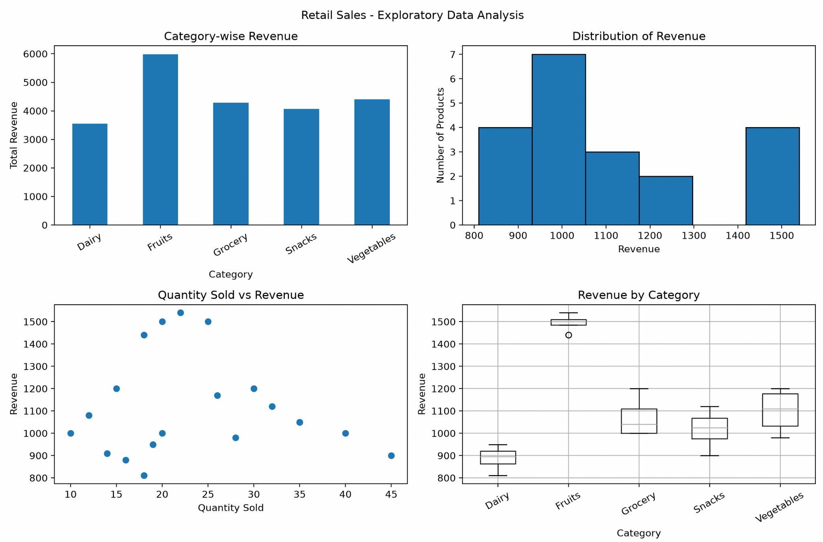

Observations
- Snacks have the highest total quantity sold, with 152 units.
- Fruits generate the highest total revenue of 5980.
- Product PR12 has the highest quantity sold, with 45 units.
- Product PR09 generates the highest revenue of 1540.
- Revenue varies across products and categories, indicating differences in sales performance.

Conclusion
Exploratory Data Analysis was successfully performed on the Retail Sales Dataset using Python, Pandas and Matplotlib. The dataset was examined using descriptive statistics and four visualizations displayed in a single figure using subplots. The analysis shows that snacks have the highest sales volume, while fruits generate the highest total revenue. These findings can help the supermarket understand product performance and make informed inventory and sales decisions.

Banking Loan Approval Dataset Question 4
A bank wants to analyze loan approval decisions based on income, credit score, loan amount, employment type, and approval status. Perform EDA to identify patterns related to loan approval.
Customer_I D | Incom e | Credit_Scor e | Loan_Amount | Employment_Typ e | Loan_Status
C01 | 45000 | 720 | 200000 | Salaried | Approved
C02 | 25000 | 580 | 150000 | Self-employed | Rejected
C03 | 60000 | 750 | 300000 | Salaried | Approved
C04 | 22000 | 560 | 120000 | Unemployed | Rejected
C05 | 50000 | 710 | 250000 | Salaried | Approved
C06 | 30000 | 600 | 180000 | Self-employed | Rejected
C07 | 70000 | 780 | 350000 | Salaried | Approved
C08 | 28000 | 590 | 160000 | Self-employed | Rejected
C09 | 55000 | 730 | 270000 | Salaried | Approved
C10 | 24000 | 570 | 130000 | Unemployed | Rejected
C11 | 65000 | 760 | 320000 | Salaried | Approved
C12 | 35000 | 620 | 200000 | Self-employed | Rejected
C13 | 48000 | 700 | 240000 | Salaried | Approved
C14 | 26000 | 585 | 140000 | Unemployed | Rejected
C15 | 75000 | 790 | 400000 | Salaried | Approved
C16 | 32000 | 610 | 190000 | Self-employed | Rejected
C17 | 52000 | 725 | 260000 | Salaried | Approved
C18 | 27000 | 575 | 150000 | Self-employed | Rejected
C19 | 68000 | 770 | 330000 | Salaried | Approved
C20 | 23000 | 555 | 125000 | Unemployed | Rejected

ANSWER:

import pandas as pd
import matplotlib.pyplot as plt

# Create the dataset data = {
"Customer_ID": [
"C01", "C02", "C03", "C04", "C05",
"C06", "C07", "C08", "C09", "C10",
"C11", "C12", "C13", "C14", "C15",
"C16", "C17", "C18", "C19", "C20"
],
"Income": [
45000, 25000, 60000, 22000, 50000,
30000, 70000, 28000, 55000, 24000,
65000, 35000, 48000, 26000, 75000,
32000, 52000, 27000, 68000, 23000
],
"Credit_Score": [

720, 580, 750, 560, 710, 600, 780, 590, 730, 570,
760, 620, 700, 585, 790, 610, 725, 575, 770, 555
],
"Loan_Amount": [
200000, 150000, 300000, 120000, 250000,
180000, 350000, 160000, 270000, 130000,
320000, 200000, 240000, 140000, 400000,
190000, 260000, 150000, 330000, 125000
],
"Employment_Type": [
"Salaried", "Self-employed", "Salaried", "Unemployed", "Salaried", "Self-employed", "Salaried", "Self-employed", "Salaried", "Unemployed", "Salaried", "Self-employed", "Salaried", "Unemployed", "Salaried", "Self-employed", "Salaried", "Self-employed", "Salaried", "Unemployed"
],
"Loan_Status": [
"Approved", "Rejected", "Approved", "Rejected", "Approved", "Rejected", "Approved", "Rejected", "Approved", "Rejected", "Approved", "Rejected", "Approved", "Rejected", "Approved", "Rejected", "Approved", "Rejected", "Approved", "Rejected"
]
}
df = pd.DataFrame(data) # Display the dataset
print("BANKING LOAN APPROVAL DATASET")
print(df)
# 1. Number of rows and columns print("\n1. SHAPE OF DATASET")
print("Number of rows:", df.shape[0]) print("Number of columns:", df.shape[1])
# 2. Data types
print("\n2. DATA TYPES") print(df.dtypes)
# 3. Missing and duplicate values print("\n3. MISSING VALUES")
print(df.isnull().sum())
print("Duplicate rows:", df.duplicated().sum()) print("Duplicate Customer IDs:",
df["Customer_ID"].duplicated().sum())
# 4. Statistical analysis
numeric_cols = ["Income", "Credit_Score", "Loan_Amount"]

print("\n4. DESCRIPTIVE STATISTICS")
print(df[numeric_cols].describe())
print("\nMEDIAN") print(df[numeric_cols].median())
print("\nSTANDARD DEVIATION")
print(df[numeric_cols].std())
print("\nAVERAGE VALUES BY LOAN STATUS")
print(
df.groupby("Loan_Status")[numeric_cols]
.mean().round(2)
)
print("\nLOAN STATUS COUNTS")
print(df["Loan_Status"].value_counts())
print("\nLOAN STATUS BY EMPLOYMENT TYPE")
print(pd.crosstab(
df["Employment_Type"], df["Loan_Status"]
))
# 5. Four charts using subplots
fig, axes = plt.subplots(2, 2, figsize=(12, 8))
# Chart 1: Bar chart of loan status df["Loan_Status"].value_counts().reindex(
["Approved", "Rejected"], fill_value=0
).plot(kind="bar", ax=axes[0, 0])
axes[0, 0].set_title("Loan Approval Status") axes[0, 0].set_xlabel("Loan Status")
axes[0, 0].set_ylabel("Number of Customers") axes[0, 0].tick_params(axis="x", rotation=0)

# Chart 2: Histogram of income axes[0, 1].hist(
df["Income"], bins=6, edgecolor="black"
)

axes[0, 1].set_title("Distribution of Customer Income") axes[0, 1].set_xlabel("Income")
axes[0, 1].set_ylabel("Number of Customers")

# Chart 3: Scatter plot of credit score and loan amount for status in ["Approved", "Rejected"]:
subset = df[df["Loan_Status"] == status] axes[1, 0].scatter(

subset["Credit_Score"], subset["Loan_Amount"], label=status
)
axes[1, 0].set_title("Credit Score vs Loan Amount") axes[1, 0].set_xlabel("Credit Score")
axes[1, 0].set_ylabel("Loan Amount") axes[1, 0].legend()
# Chart 4: Box plot of income by loan status df.boxplot(
column="Income", by="Loan_Status", ax=axes[1, 1]
)
axes[1, 1].set_title("Income by Loan Status") axes[1, 1].set_xlabel("Loan Status")
axes[1, 1].set_ylabel("Income")
# Display all four charts in one figure fig.suptitle("Banking Loan Approval - EDA") plt.tight_layout()
plt.show()

OUTPUT:
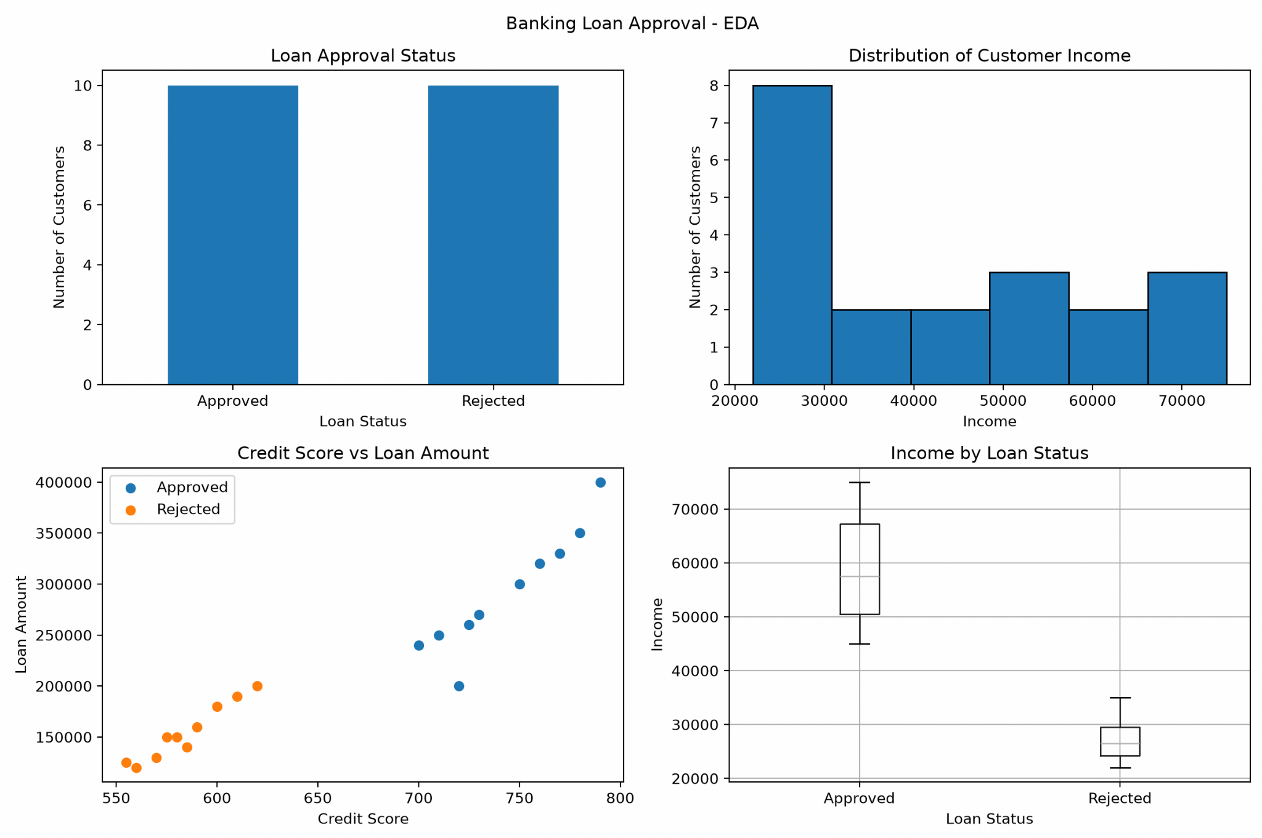

Observations
- Out of 20 customers, 10 loans were approved and 10 were rejected.
- Approved customers have a higher average income of 58,800 than rejected customers, whose average income is 27,200.
- Approved customers have a higher average credit score of 743.5, while rejected customers have an average credit score of 584.5.
- The average loan amount is 292,000 for approved customers and 154,500 for rejected customers.
- All approved customers in this dataset are salaried, while rejected customers are self-employed or unemployed.

Conclusion
Exploratory Data Analysis was successfully performed on the Banking Loan Approval Dataset using Python, Pandas and Matplotlib. The dataset was analyzed using descriptive statistics and four visualizations displayed in a single figure using subplots. The analysis indicates that income, credit score and employment type are associated with loan approval status in this dataset. These patterns may help banks explore loan

applications, but actual lending decisions require broader data and appropriate assessment criteria.

Agriculture Crop Yield Dataset Question 5
An agricultural department wants to analyze crop yield based on rainfall, temperature, fertilizer usage, soil type, and crop yield. Perform EDA to identify the factors influencing crop production.
Farm_I D | Rainfall_m m | Temperatur e | Fertilizer_k g | Soil_Typ e | Crop_Yield_k g
F01 | 850 | 28 | 60 | Loamy | 3200
F02 | 600 | 32 | 45 | Sandy | 2100
F03 | 900 | 27 | 65 | Loamy | 3500
F04 | 500 | 34 | 40 | Sandy | 1800
F05 | 780 | 29 | 55 | Clay | 3000
F06 | 650 | 31 | 48 | Sandy | 2300
F07 | 920 | 26 | 70 | Loamy | 3700
F08 | 720 | 30 | 52 | Clay | 2800
F09 | 550 | 33 | 42 | Sandy | 1900
F10 | 800 | 28 | 58 | Loamy | 3100
F11 | 880 | 27 | 62 | Loamy | 3400
F12 | 620 | 32 | 46 | Sandy | 2200
F13 | 760 | 29 | 54 | Clay | 2950
F14 | 940 | 26 | 72 | Loamy | 3800
F15 | 580 | 33 | 44 | Sandy | 2000
F16 | 820 | 28 | 60 | Clay | 3150
F17 | 700 | 30 | 50 | Clay | 2700
F18 | 960 | 25 | 75 | Loamy | 3900
F19 | 540 | 34 | 41 | Sandy | 1850
F20 | 790 | 29 | 56 | Clay | 3050

ANSWER:

import pandas as pd
import matplotlib.pyplot as plt

# Create the dataset data = {
"Farm_ID": [
"F01", "F02", "F03", "F04", "F05",
"F06", "F07", "F08", "F09", "F10",
"F11", "F12", "F13", "F14", "F15",
"F16", "F17", "F18", "F19", "F20"
],
"Rainfall_mm": [
850, 600, 900, 500, 780, 650, 920, 720, 550, 800,
880, 620, 760, 940, 580, 820, 700, 960, 540, 790
],

"Temperature": [
28, 32, 27, 34, 29, 31, 26, 30, 33, 28,
27, 32, 29, 26, 33, 28, 30, 25, 34, 29
],
"Fertilizer_kg": [
60, 45, 65, 40, 55, 48, 70, 52, 42, 58,
62, 46, 54, 72, 44, 60, 50, 75, 41, 56
],
"Soil_Type": [
"Loamy", "Sandy", "Loamy", "Sandy", "Clay",
"Sandy", "Loamy", "Clay", "Sandy", "Loamy",
"Loamy", "Sandy", "Clay", "Loamy", "Sandy",
"Clay", "Clay", "Loamy", "Sandy", "Clay"
],
"Crop_Yield_kg": [
3200, 2100, 3500, 1800, 3000, 2300, 3700, 2800,
1900, 3100, 3400, 2200, 2950, 3800, 2000,
3150, 2700, 3900, 1850, 3050
]
}
df = pd.DataFrame(data) # Display the dataset
print("AGRICULTURE CROP YIELD DATASET")
print(df)
# 1. Number of rows and columns print("\n1. SHAPE OF DATASET")
print("Number of rows:", df.shape[0]) print("Number of columns:", df.shape[1])
# 2. Data types
print("\n2. DATA TYPES") print(df.dtypes)
# 3. Missing and duplicate values print("\n3. MISSING VALUES")
print(df.isnull().sum())
print("Duplicate rows:", df.duplicated().sum()) print("Duplicate Farm IDs:",
df["Farm_ID"].duplicated().sum())
# 4. Statistical analysis numeric_cols = [
"Rainfall_mm", "Temperature", "Fertilizer_kg", "Crop_Yield_kg"
]

print("\n4. DESCRIPTIVE STATISTICS")
print(df[numeric_cols].describe())
print("\nMEDIAN") print(df[numeric_cols].median())
print("\nSTANDARD DEVIATION")
print(df[numeric_cols].std())
print("\nAVERAGE CROP YIELD BY SOIL TYPE")
print(df.groupby("Soil_Type")["Crop_Yield_kg"].mean().round(2))
# 5. Four charts using subplots
fig, axes = plt.subplots(2, 2, figsize=(12, 8))
# Chart 1: Bar chart of average yield by soil type
soil_yield = df.groupby("Soil_Type")["Crop_Yield_kg"].mean() soil_yield.plot(kind="bar", ax=axes[0, 0])
axes[0, 0].set_title("Average Crop Yield by Soil Type") axes[0, 0].set_xlabel("Soil Type")
axes[0, 0].set_ylabel("Average Crop Yield (kg)") axes[0, 0].tick_params(axis="x", rotation=0)
# Chart 2: Histogram of crop yield axes[0, 1].hist(
df["Crop_Yield_kg"], bins=6, edgecolor="black"
)
axes[0, 1].set_title("Distribution of Crop Yield") axes[0, 1].set_xlabel("Crop Yield (kg)") axes[0, 1].set_ylabel("Number of Farms")
# Chart 3: Scatter plot of rainfall vs crop yield axes[1, 0].scatter(
df["Rainfall_mm"], df["Crop_Yield_kg"]
)
axes[1, 0].set_title("Rainfall vs Crop Yield") axes[1, 0].set_xlabel("Rainfall (mm)") axes[1, 0].set_ylabel("Crop Yield (kg)")

# Chart 4: Box plot of crop yield by soil type df.boxplot(
column="Crop_Yield_kg", by="Soil_Type", ax=axes[1, 1]
)

axes[1, 1].set_title("Crop Yield by Soil Type") axes[1, 1].set_xlabel("Soil Type")
axes[1, 1].set_ylabel("Crop Yield (kg)")
# Display all four charts in one figure fig.suptitle("Agriculture Crop Yield - EDA") plt.tight_layout()
plt.show()

OUTPUT:

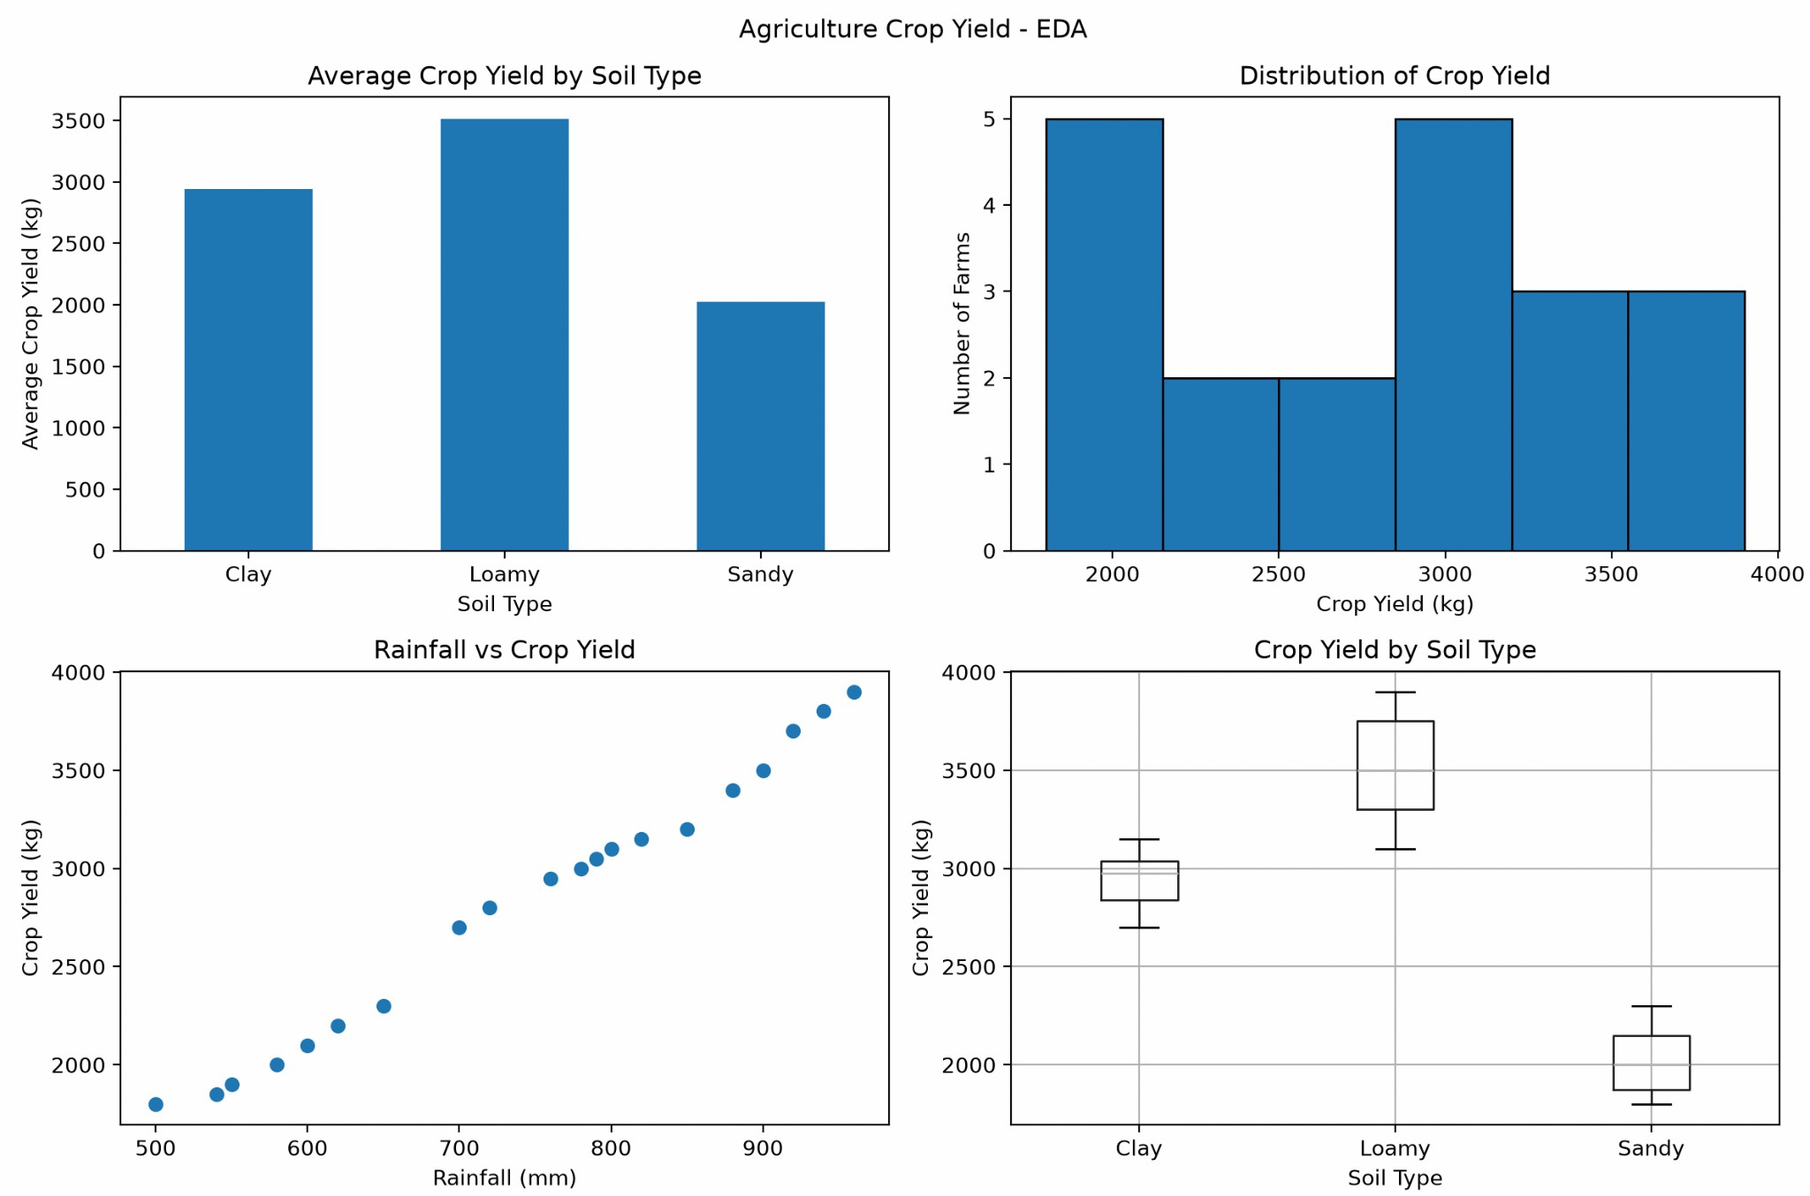

Observations
- Farm F18 recorded the highest crop yield of 3900 kg, while farm F04 recorded the lowest yield of 1800 kg.
- Loamy soil has the highest average crop yield, approximately 3514.29 kg.
- Farms with higher rainfall generally show higher crop yields in this dataset.
- Higher fertilizer usage is generally associated with higher crop yield.
- Lower temperatures are associated with higher yields in the given data, although other factors may also influence production.

Conclusion
Exploratory Data Analysis was successfully performed on the Agriculture Crop Yield Dataset using Python, Pandas and Matplotlib. The dataset was analyzed using descriptive statistics and four visualizations displayed in a single figure using subplots. The analysis indicates that rainfall, fertilizer usage, temperature and soil type are associated with crop yield. Loamy soil has the highest average yield among the three soil types. These findings can help guide further agricultural analysis, although the dataset alone cannot establish cause-and-effect relationships.

RUBRICS FOR CALCULATION

Exploratory Data Analysis-Based Practical Assessment
Criteria | Weightag  e | Level 4 – Exemplary | Level 3 – Proficient | Level 2 – Developing | Level 1 – Beginning
Dataset Understanding | 20 | Clearly explains dataset source, features, target variables, data types, and problem context with strong clarity | Explains dataset, features, and variables with adequate clarity | Basic explanation of dataset with limited understanding of variables | Poor understanding of dataset; variables and problem context are unclear
Data Cleaning | 25 | Effectively identifies and handles missing values, duplicates, incorrect entries, and outliers using suitable methods | Handles most missing values, duplicates, and errors correctly | Performs basic cleaning but misses some important data quality issues | Minimal or incorrect data cleaning; major errors remain in the dataset
Data Analysis and Statistical Summary | 20 | Provides detailed descriptive statistics, comparisons, patterns, and meaningful interpretations | Provides relevant summary statistics and basic interpretation | Provides limited statistics with weak explanation | Lacks statistical analysis or gives incorrect interpretation
Data Visualization | 20 | Uses highly appropriate charts with proper labels, titles, and clear visual interpretation | Uses suitable charts with mostly clear labels and explanation | Uses limited or basic charts with unclear interpretation | Poor or incorrect visualizations; charts do not support analysis
Insight Generation and Reporting | 15 | Presents strong insights, conclusions, and recommendations based on data evidence | Presents clear findings and conclusions with reasonable support | Provides basic findings but lacks depth or proper justification | Findings are unclear, unsupported, or not related to the data

